**Mainframes DXC Australia**

**Utilities**

**By: Pranay Yara**

**JCL 3**

IEFBR14: 3

Util1a = creating a PS dataset 3

Util1b = creating a PDS dataset 3

Util1c = deleting an existing a PS/PDS dataset 3

Util1d = catalog an uncataloged dataset 4

Util1e = uncatalog an cataloged dataset 4

IEBGENER: 4

Util2a = copies between two ps files 4

Util2b = copies between a PS and pastes into a newly created PS dataset 5

Util2c = copies between from instream line into a new PS dataset 5

Util2d = outputs instream line data into spool 5

Util2e = append two PS datasets 6

Util2f = multiple step: create dataset, copy from ps dataset, appending instream lines and delete 6

Util2g = concatenation/connection multiple PS datasets into a PS dataset 7

IEBCOPY 7

Util3a = copying pds members into another newly created PDS dataset 7

Util3b = copying only selected PDS members into a newly created PDS dataset 8

Util3c = Excluding PDS members when copying into a new PDS dataset 8

Util3d = appending mems to an dataset where member already exist 8

Util3e = replacing member file with same name but different content 9

Util3f = compressing a PdS dataset 9

SORT: 9

Util4a = sorting ascending 9

Util4b = sorting duplicate rows 10

Util4c = sorting duplicate / common fields 10

Util4d = copying using sort 10

Util4e = eliminating duplicate fields 11

Util4f = eliminating dupes and adding them into a new PS dataset 11

Util4g = splitting fields into different files 12

Util4h = splitting all records into new files 12

Util4i = formatting so only two fields appear 13

Util4j = applying formatting ‘Lastname:’ 13

Util4k = conditions on fields 13

Util4l = two conditions 14

Util4m = omitting conditions 14

Util4n = merging 15

COND PARM: (not sure if this is correct) 15

GDG: 18

GDG Base 18

Creating Generations 19

INSTREAM PROCEDUREs: 19

CATALOG PROCEDURE: 20

**COBOL: 21**

Basic cobol: 21

ARITH: 23

BMS: 24

PROGRAM: 24

**CICS: 25**

INSTALL AND DEFINE: 25

QUEUE: 26

**VSAM: 28**

CREATING DATASETS: 28

LOADING: 28

UNLOAD: 30

PRINTING: 31

**DB2: 31**

# **JCL**

## IEFBR14:

### Util1a = creating a PS dataset

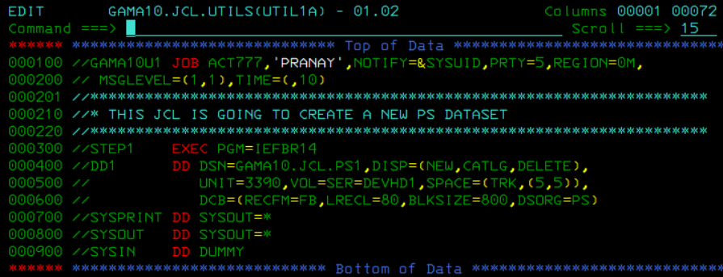

### Util1b = creating a PDS dataset

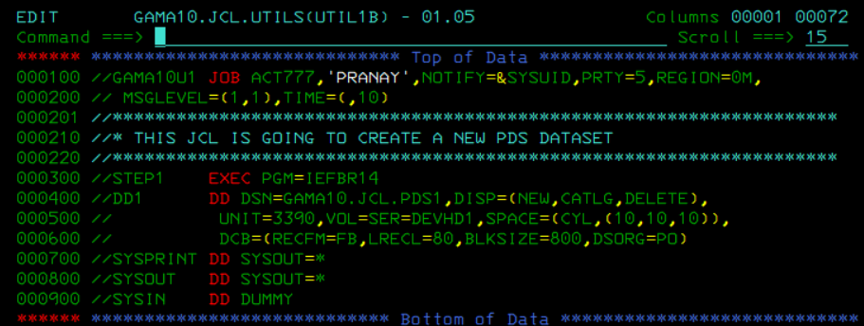

### Util1c = deleting an existing a PS/PDS dataset

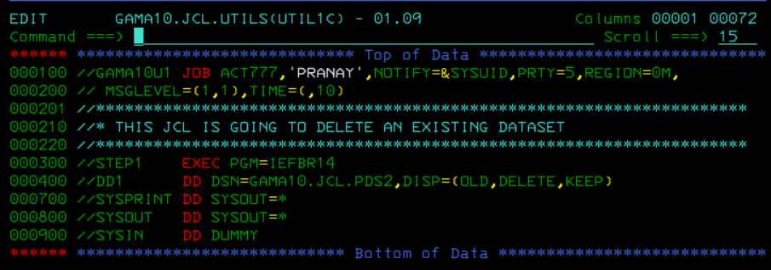

### Util1d = catalog an uncataloged dataset

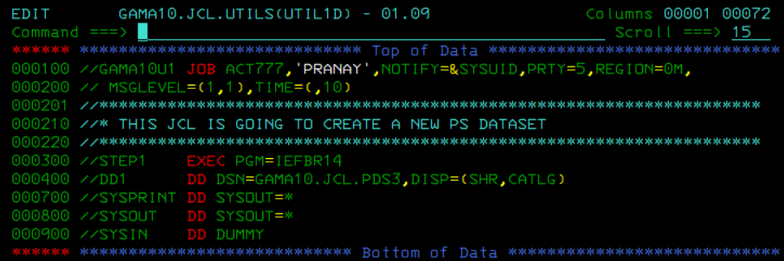

### Util1e = uncatalog an cataloged dataset

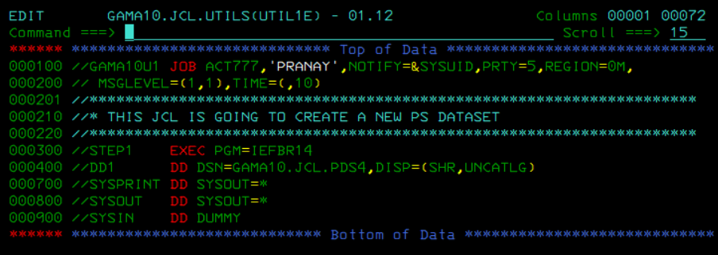

## IEBGENER:

### Util2a = copies between two ps files

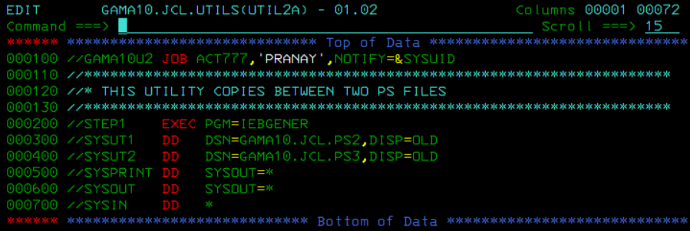

### Util2b = copies between a PS and pastes into a newly created PS dataset

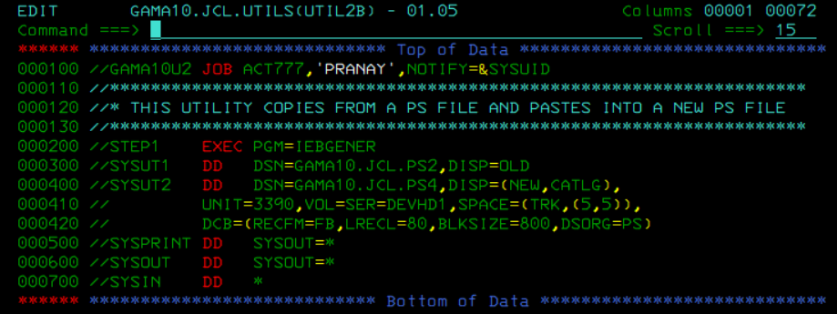

### Util2c = copies between from instream line into a new PS dataset

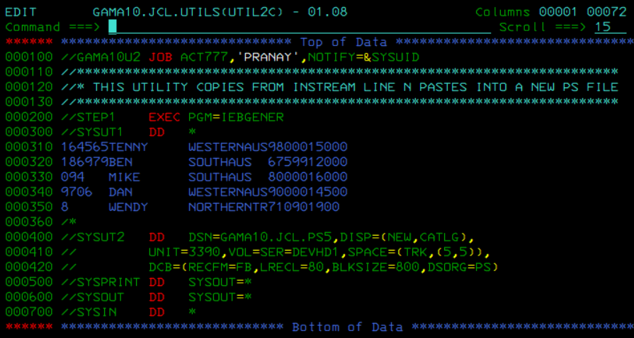

### Util2d = outputs instream line data into spool

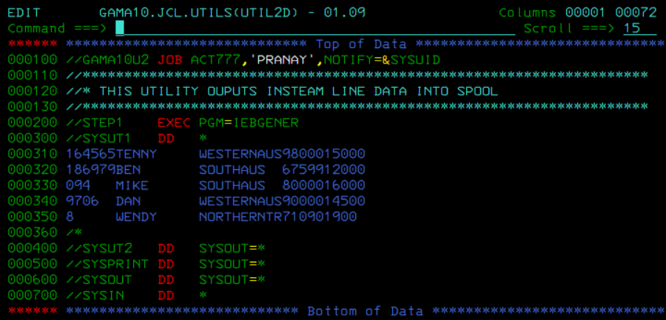

### Util2e = append two PS datasets

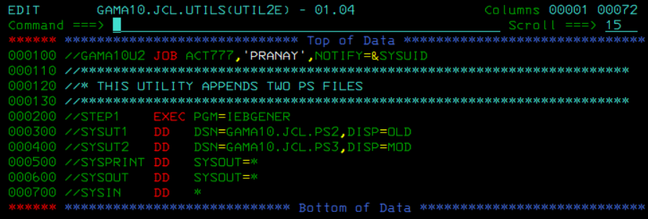

### Util2f = multiple step: create dataset, copy from ps dataset, appending instream lines and delete

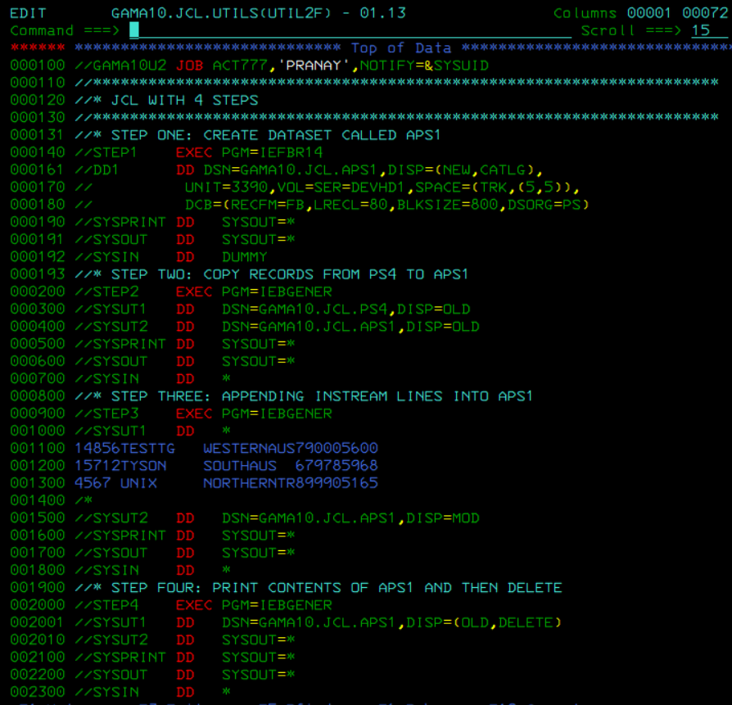

### Util2g = concatenation/connection multiple PS datasets into a PS dataset

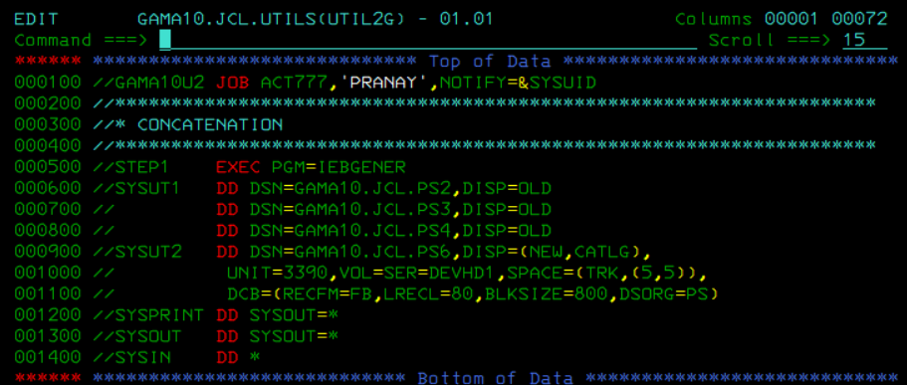

## 

## IEBCOPY

### Util3a = copying pds members into another newly created PDS dataset

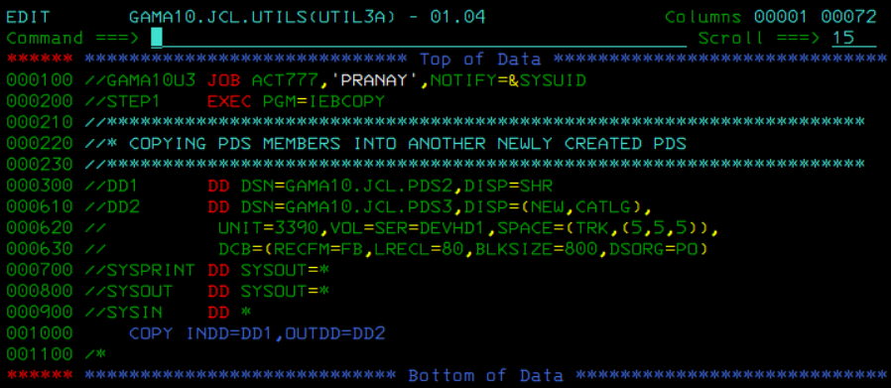

### Util3b = copying only selected PDS members into a newly created PDS dataset

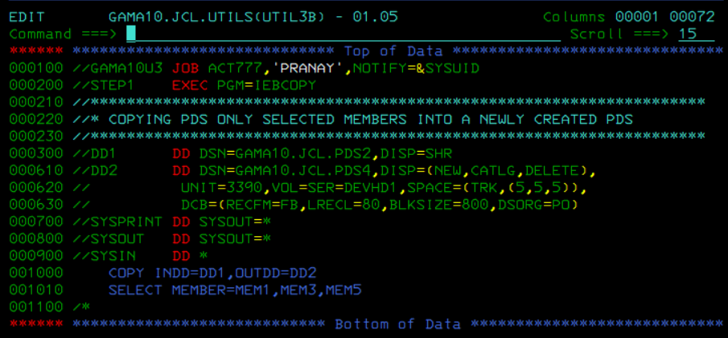

### Util3c = Excluding PDS members when copying into a new PDS dataset

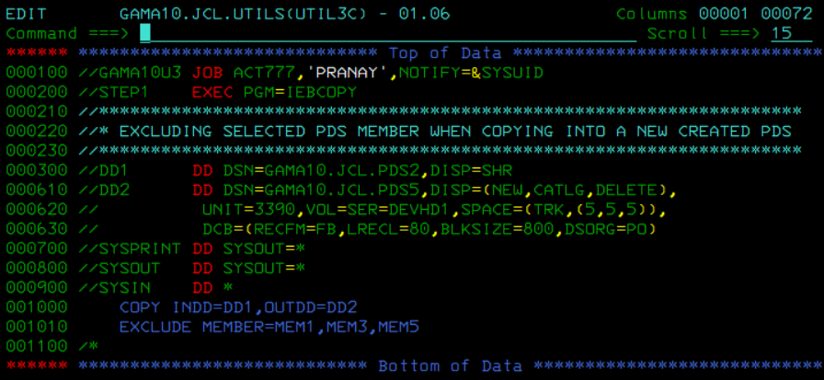

### Util3d = appending mems to an dataset where member already exist

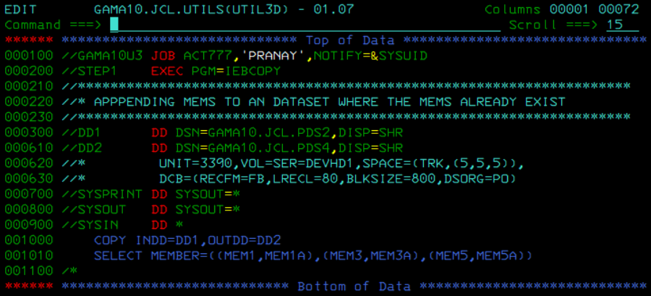

### Util3e = replacing member file with same name but different content

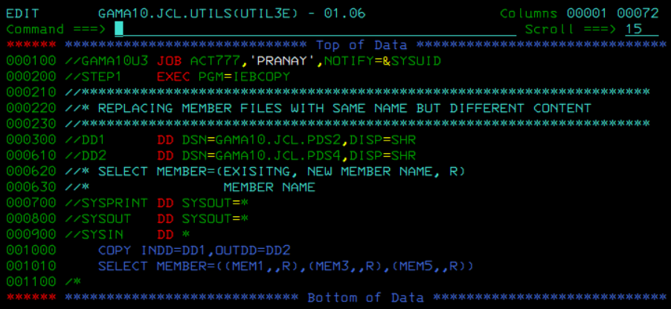

### Util3f = compressing a PdS dataset

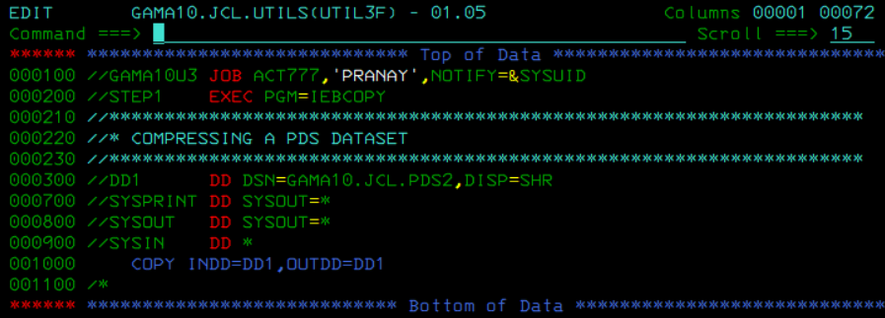

## SORT:

### Util4a = sorting ascending

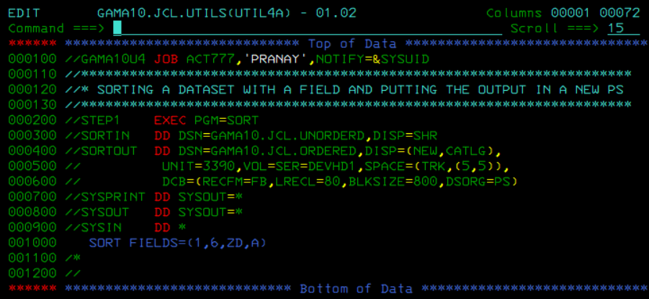

### Util4b = sorting duplicate rows

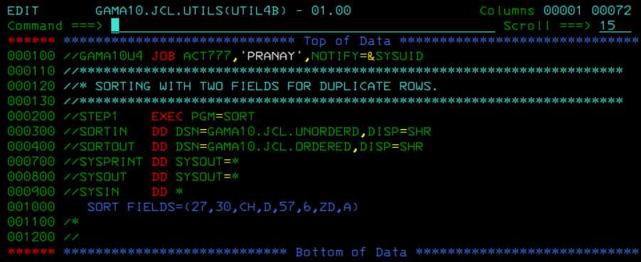

### Util4c = sorting duplicate / common fields

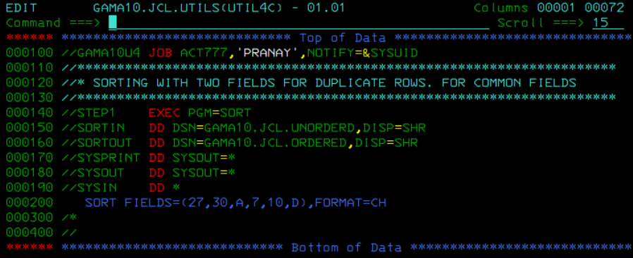

### Util4d = copying using sort

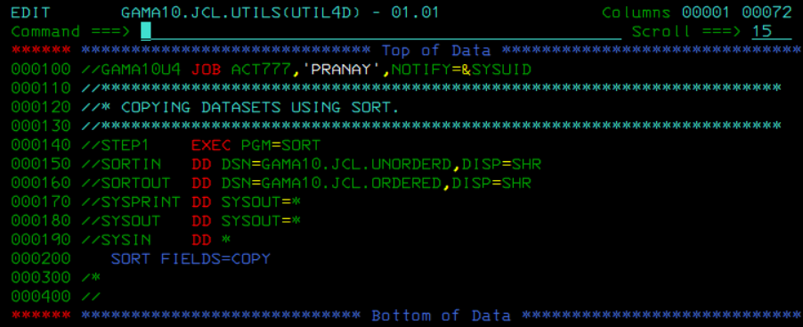

### Util4e = eliminating duplicate fields

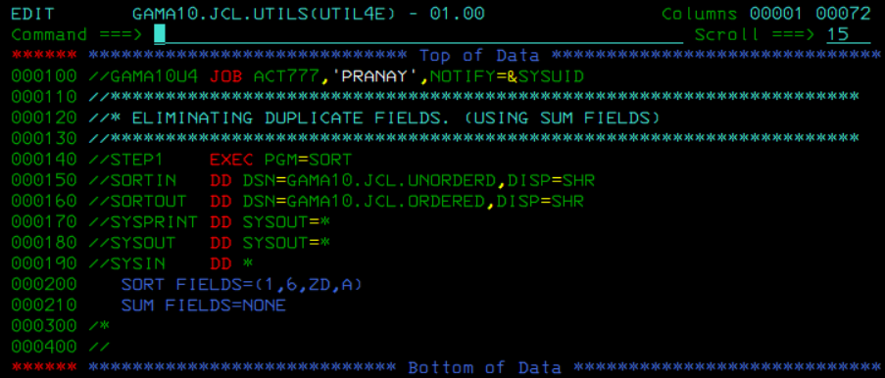

### Util4f = eliminating dupes and adding them into a new PS dataset

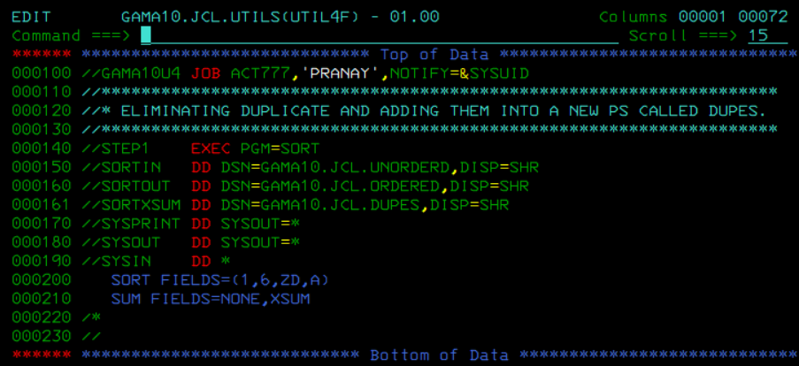

### Util4g = splitting fields into different files

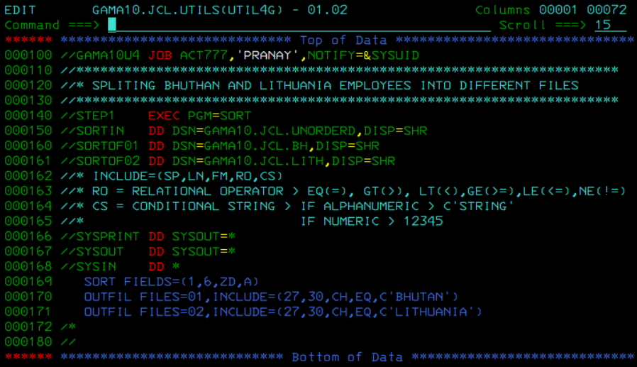

### Util4h = splitting all records into new files

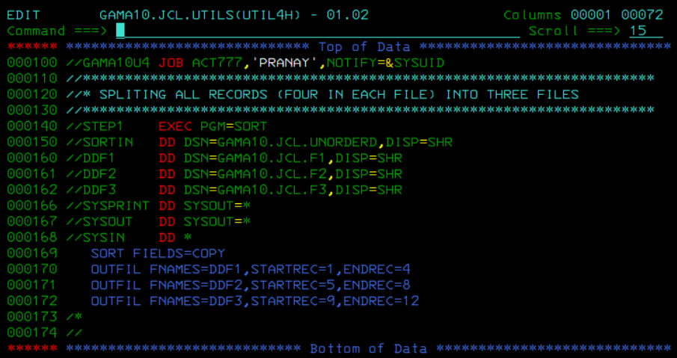

### Util4i = formatting so only two fields appear

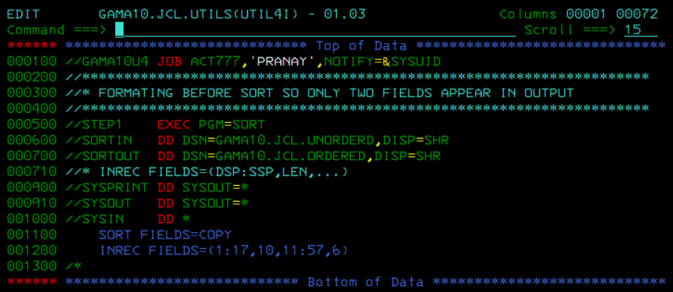

### Util4j = applying formatting ‘Lastname:’

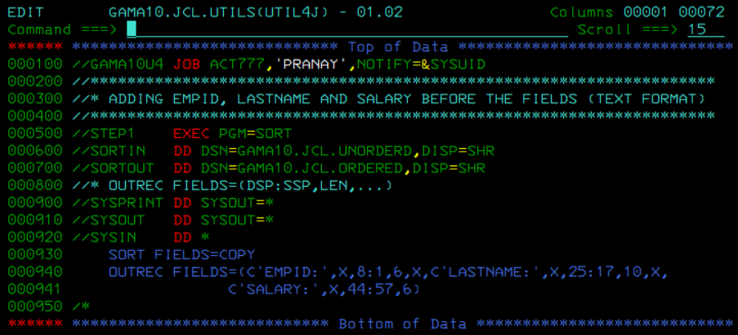

### Util4k = conditions on fields

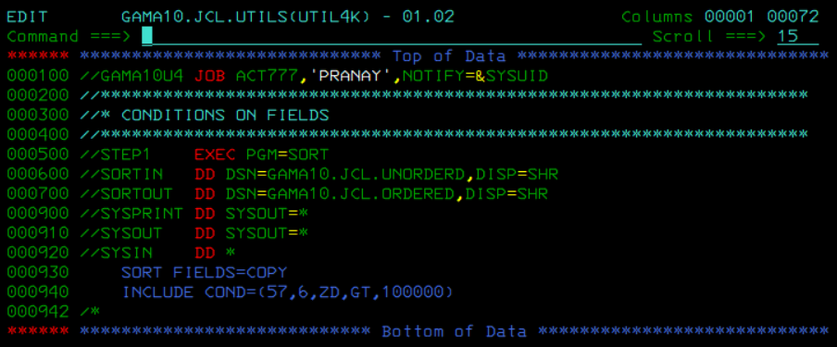

### Util4l = two conditions

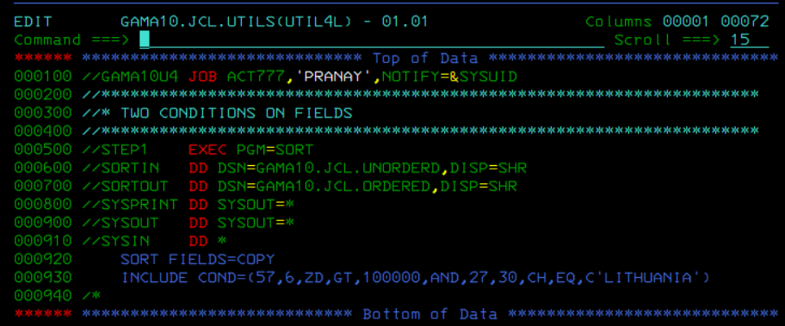

### Util4m = omitting conditions

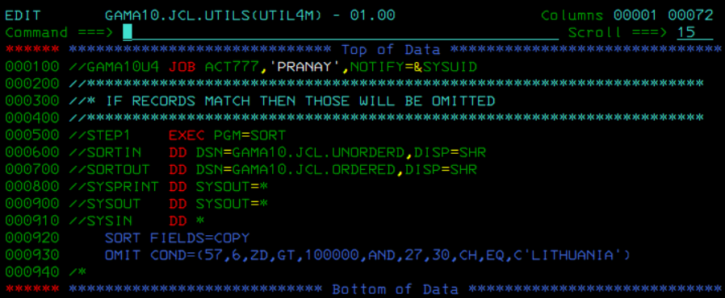

### Util4n = merging

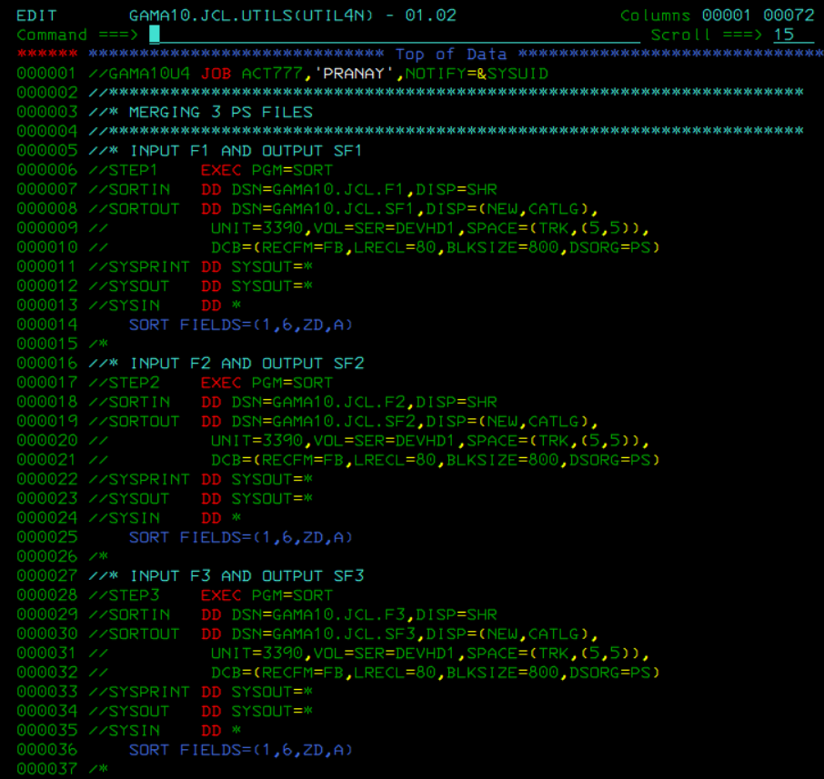

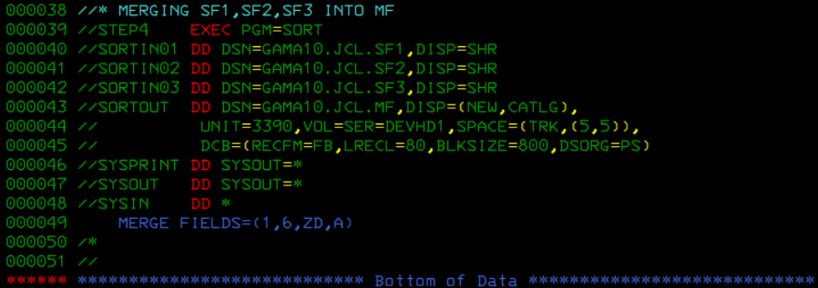

## COND PARM: (not sure if this is correct)

*I think I was getting errors back then when I was executing these codes. I was just testing and trying to learn

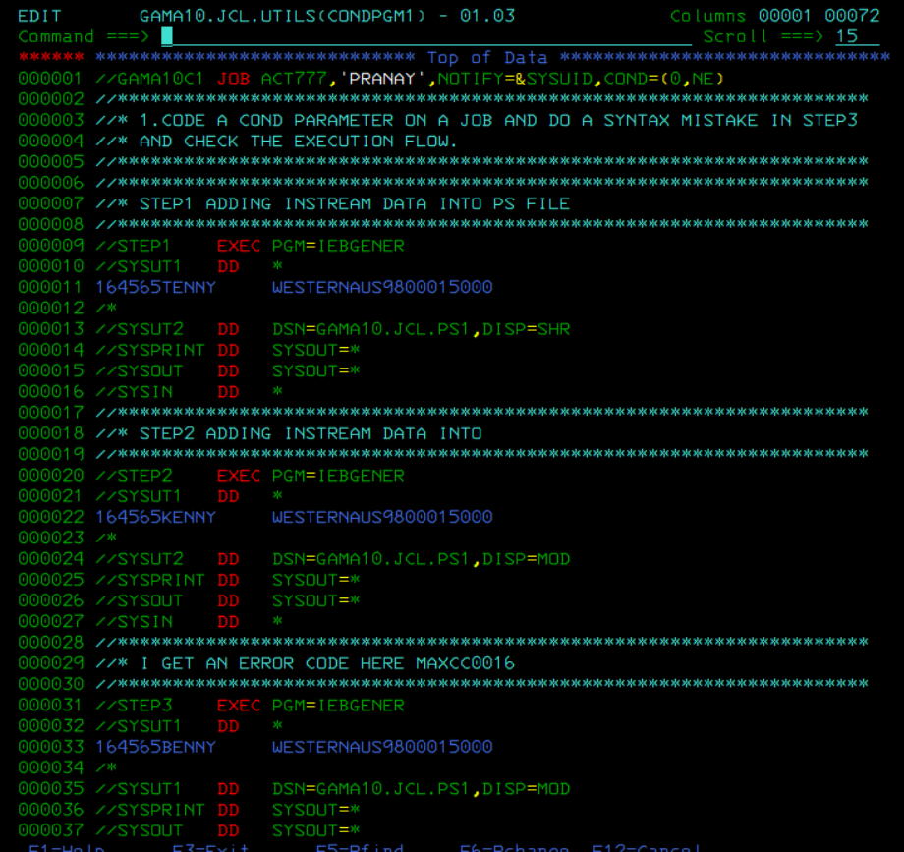

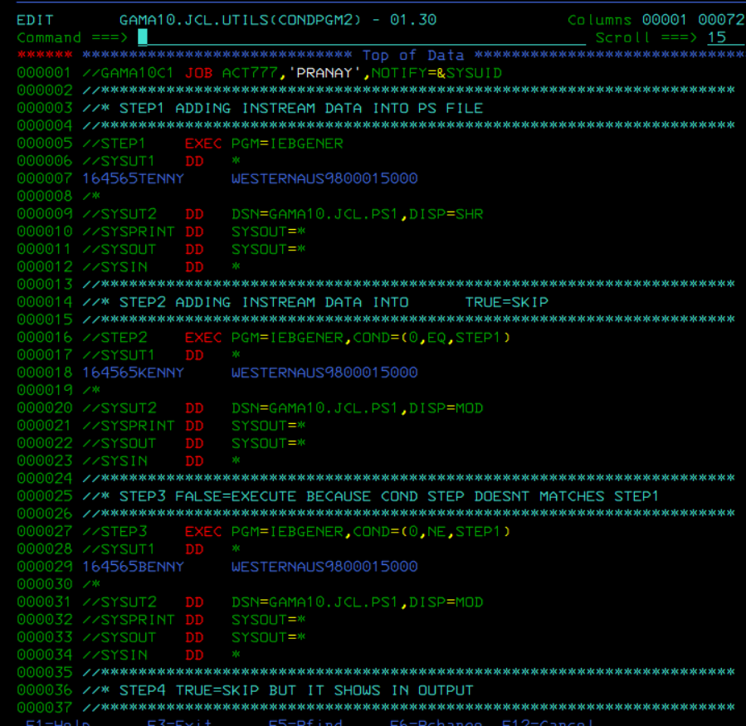

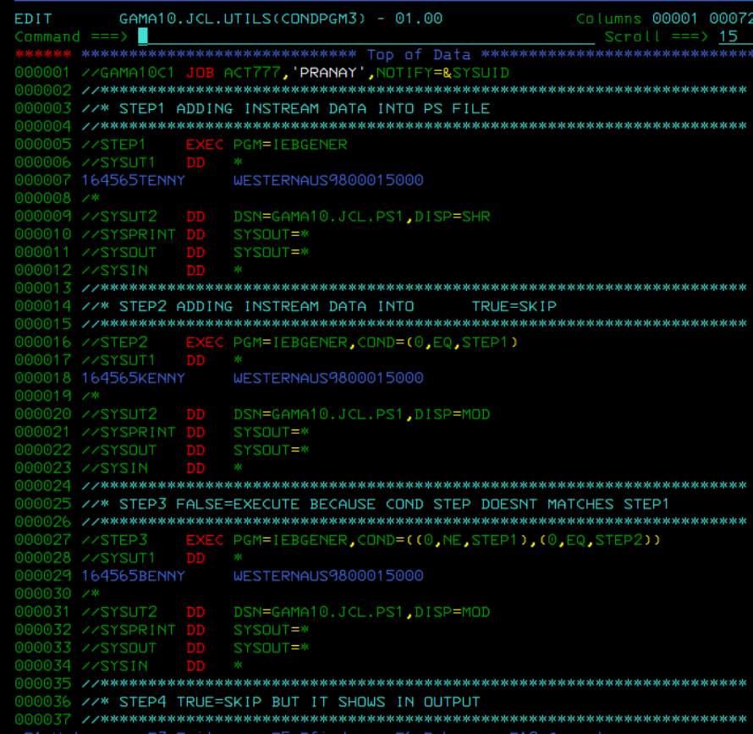

## GDG:

### GDG Base

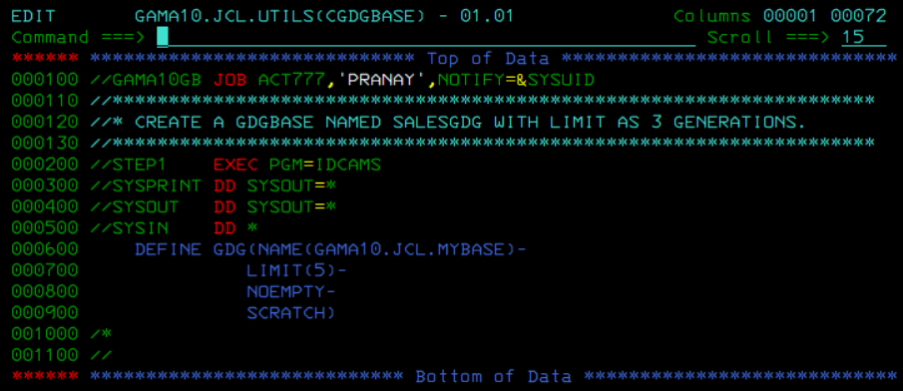

### Creating Generations

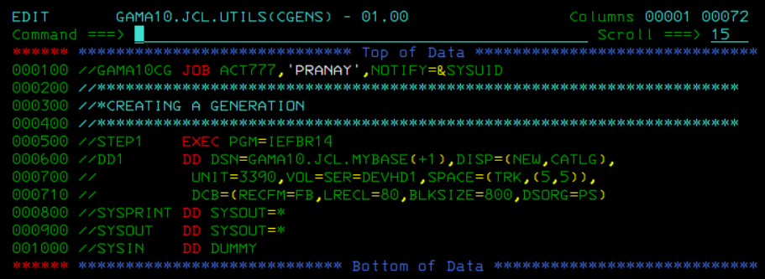

## INSTREAM PROCEDUREs:

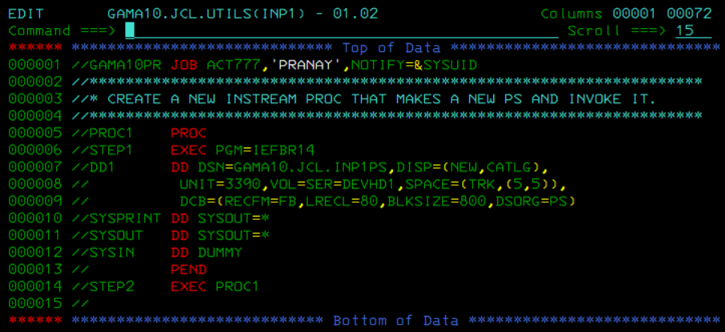

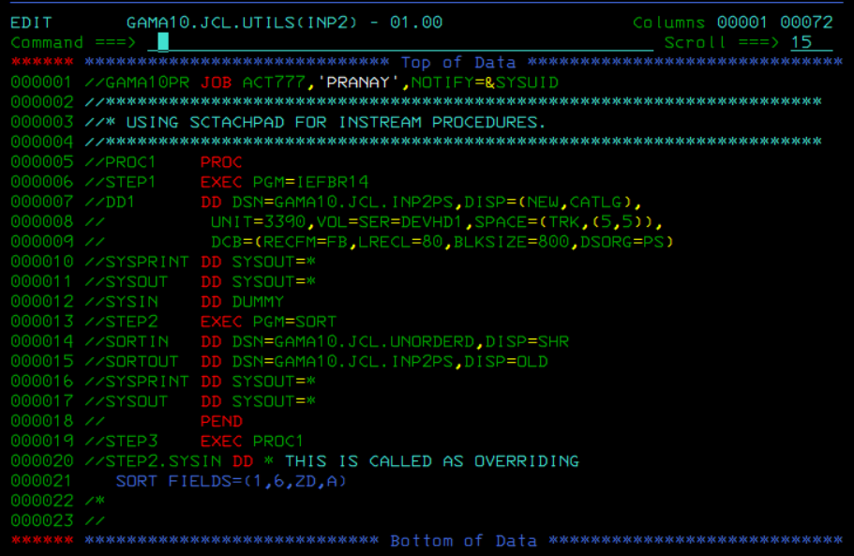

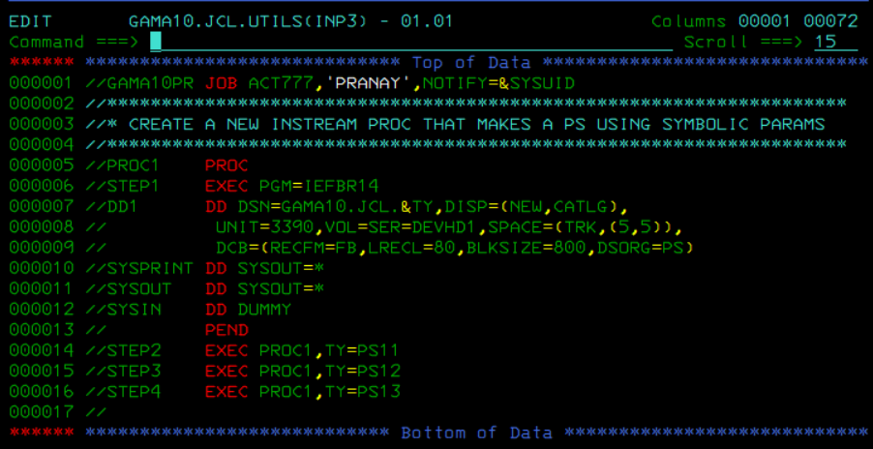

## CATALOG PROCEDURE:

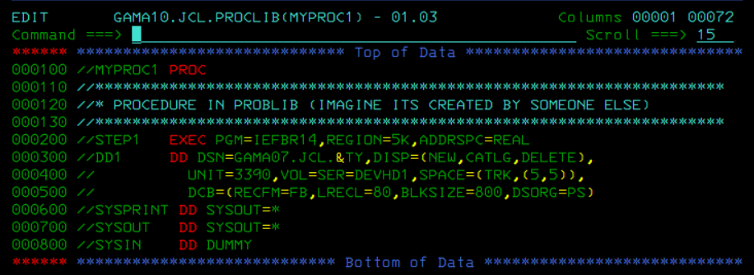

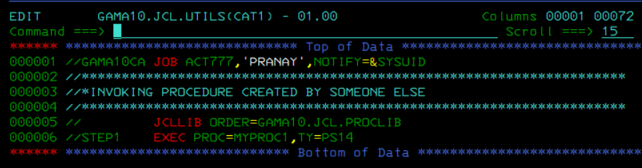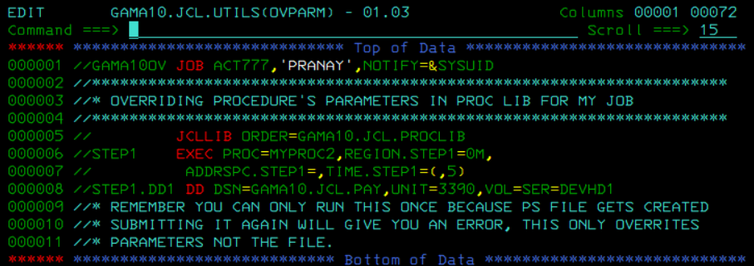

# **COBOL:**

## Basic cobol:

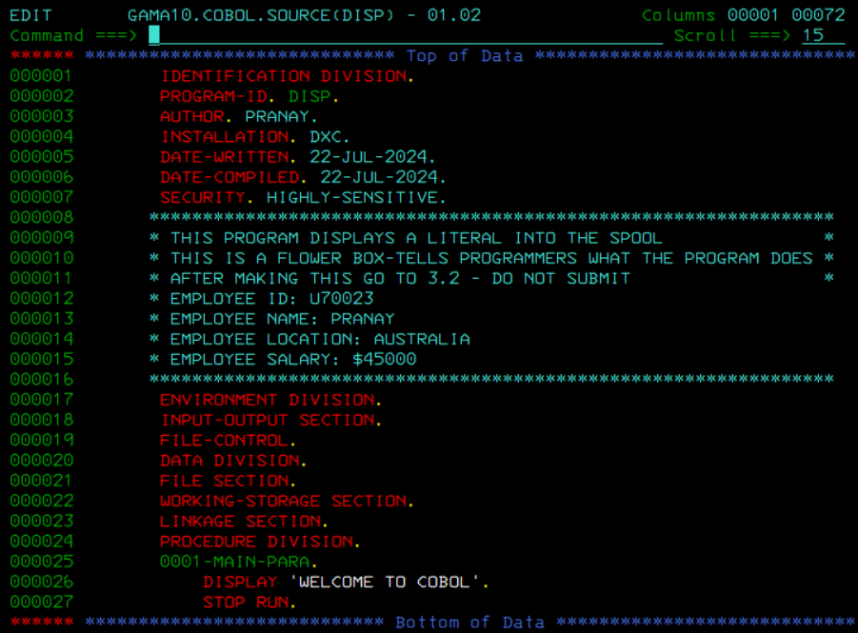

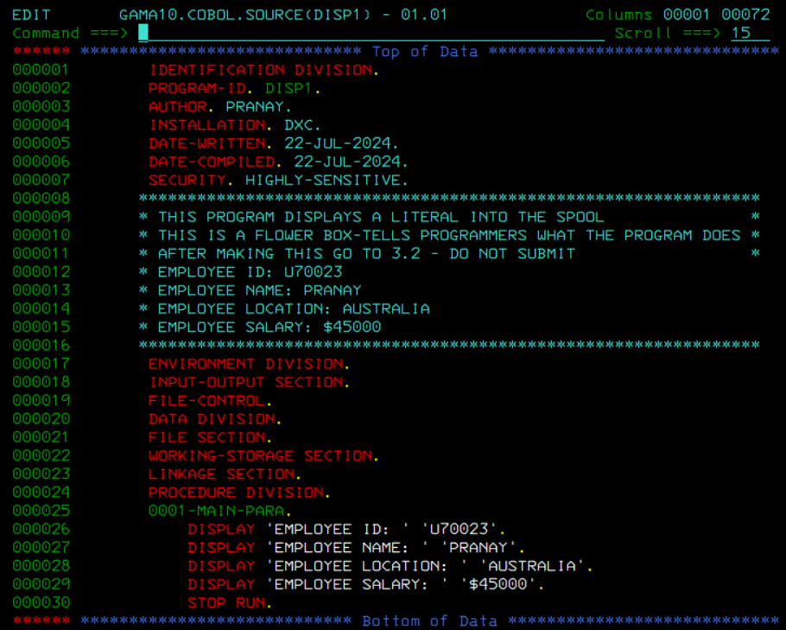

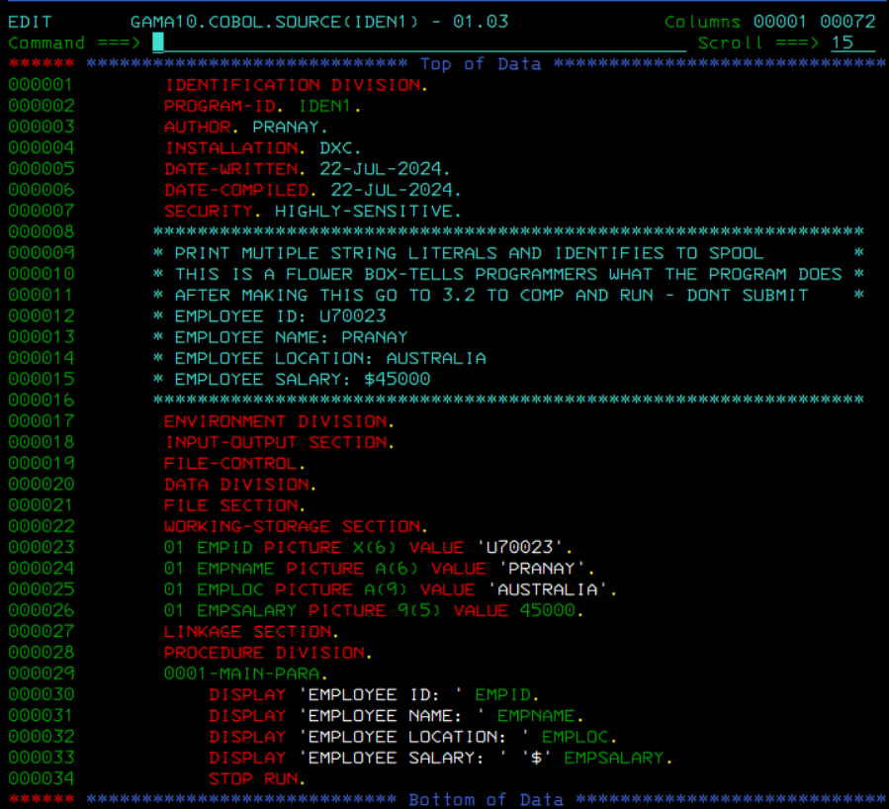

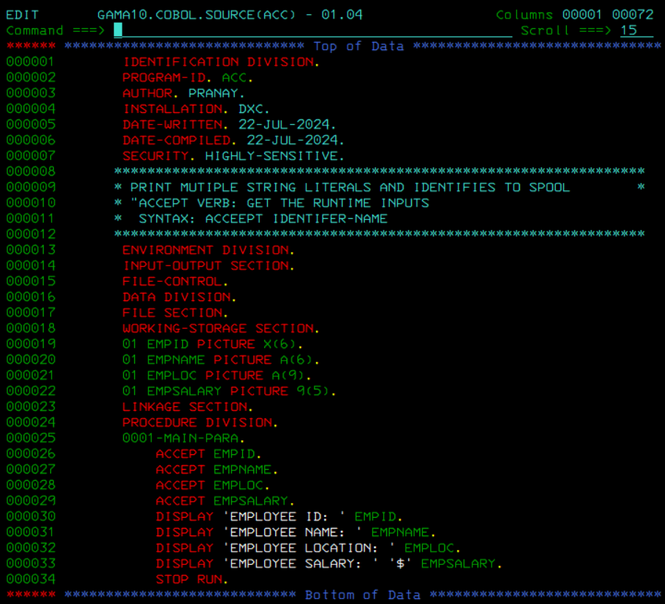

## ARITH:

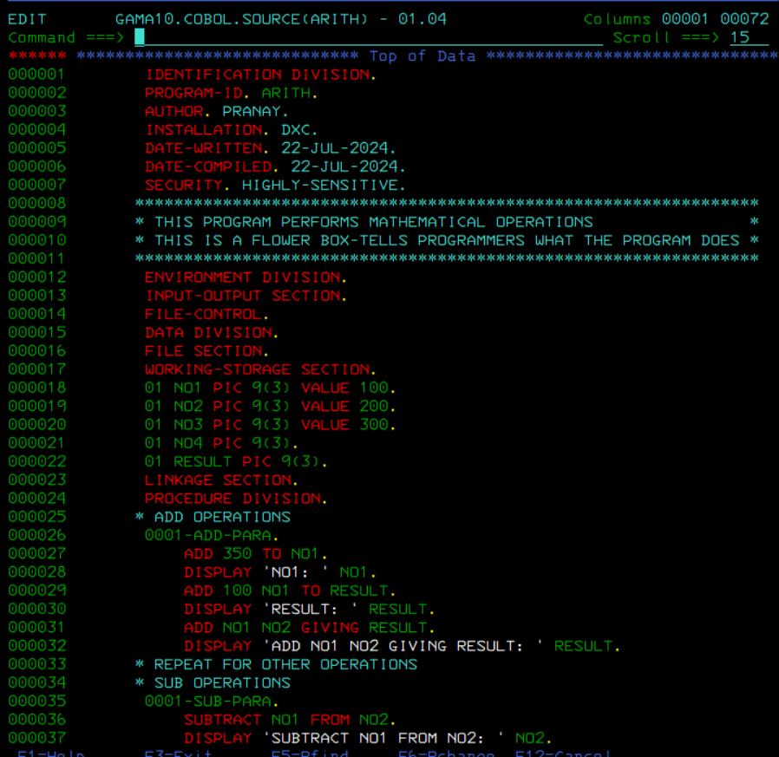

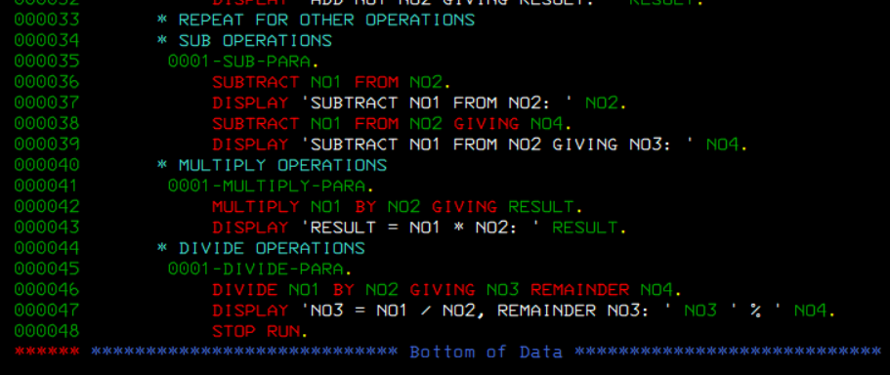

## BMS:

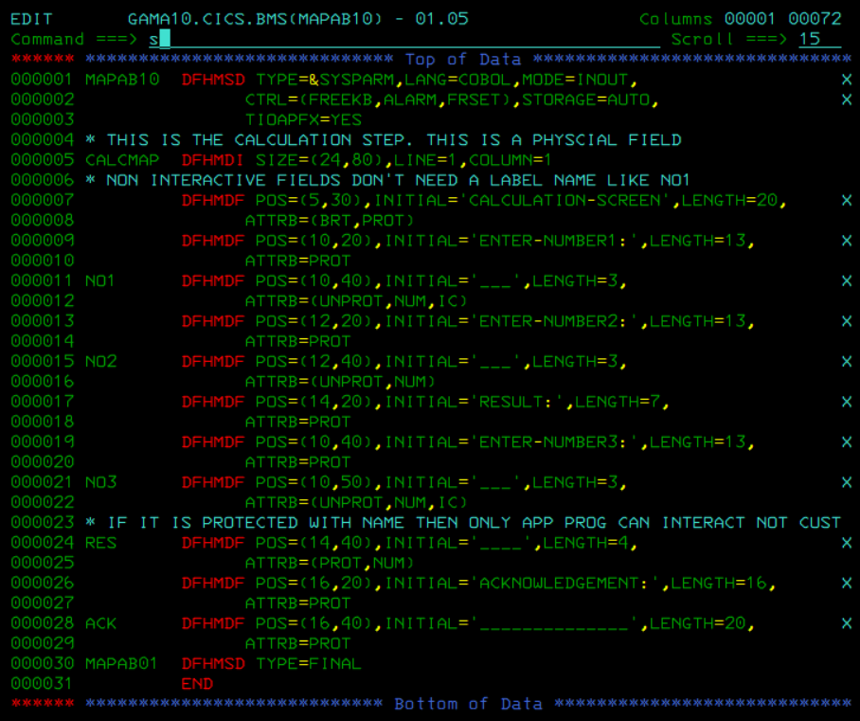

## PROGRAM:

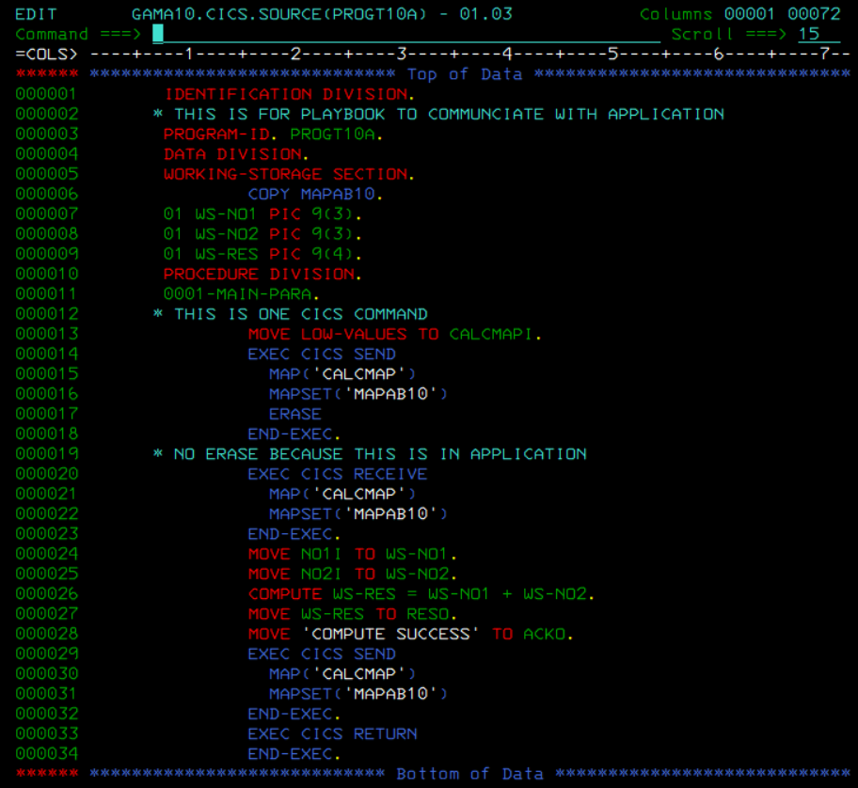

# **CICS:**

## INSTALL AND DEFINE:

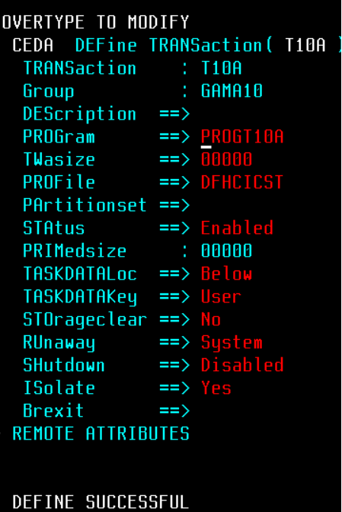

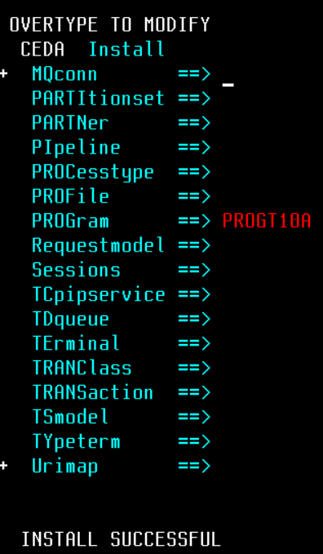

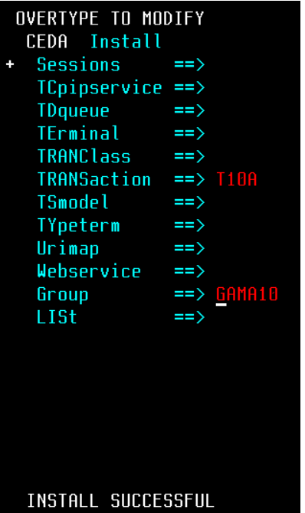

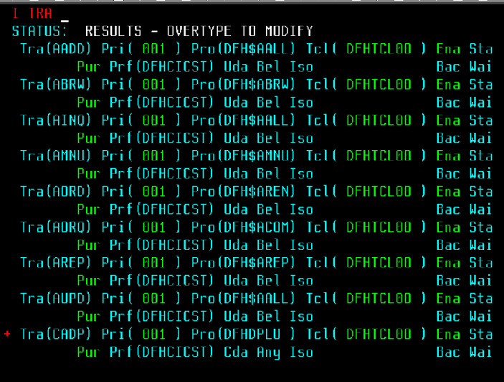

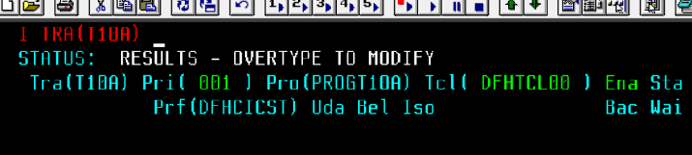

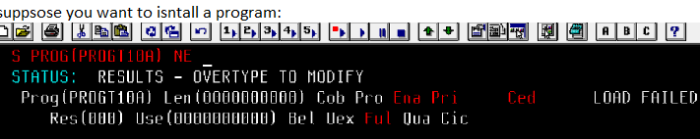

## QUEUE:



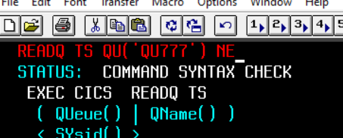

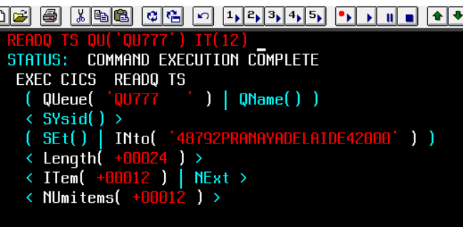

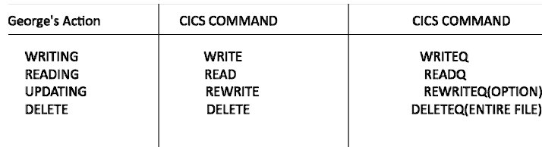

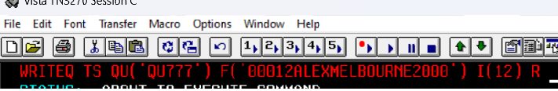

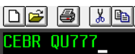

# **VSAM:**

## CREATING DATASETS:

### Creating esds cluster

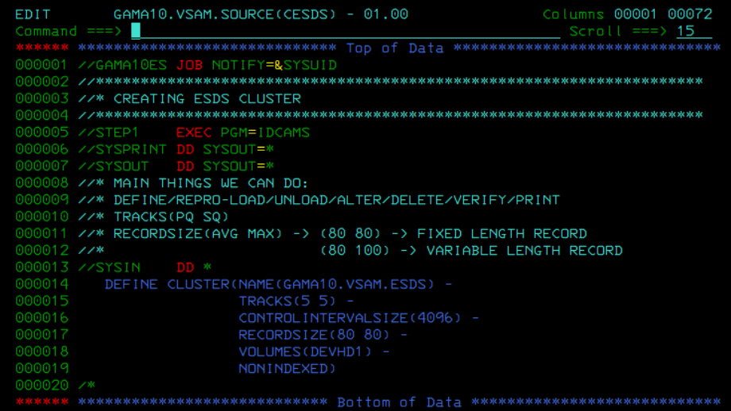

### Creating ksds cluster

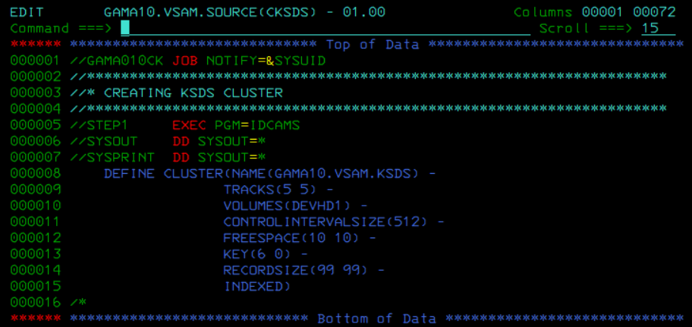

## LOADING:

### Copying from ps into cluster

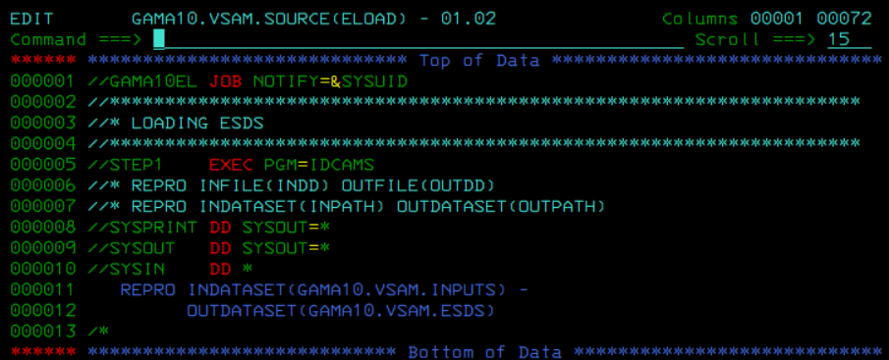

### Count / copying and appending

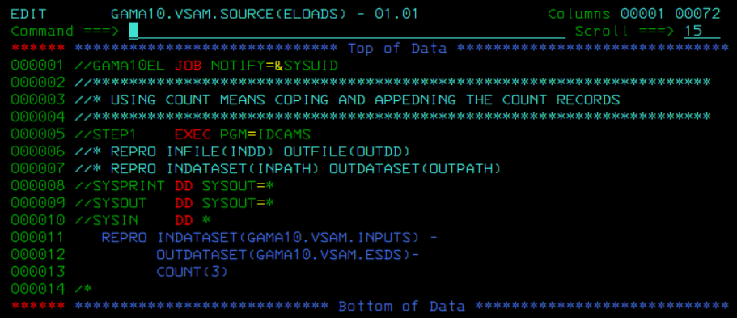

### Skip / skipping before copying records

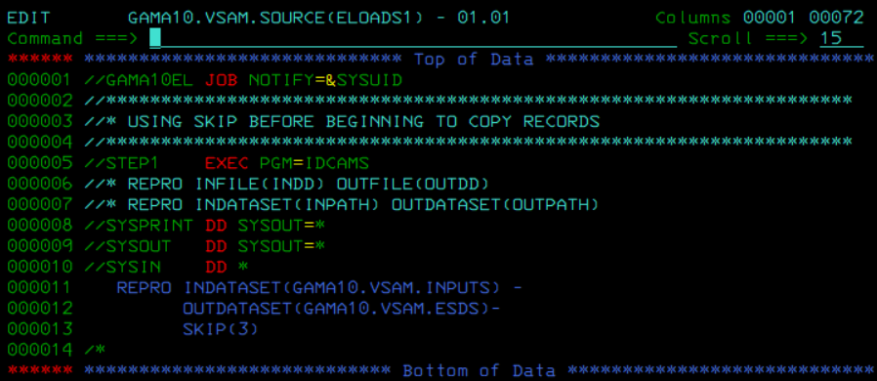

### Both Count and Skip

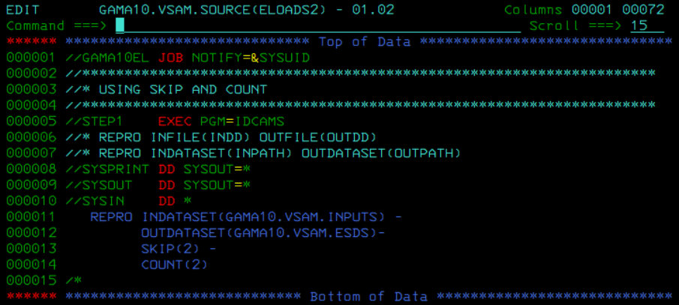

## UNLOAD:

### Sending data from cluster to ps file

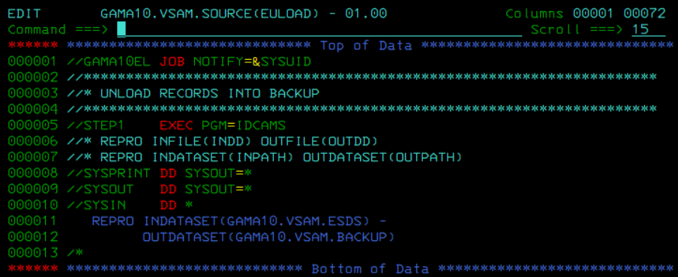

### Selecting / Fromaddress() Toaddress()

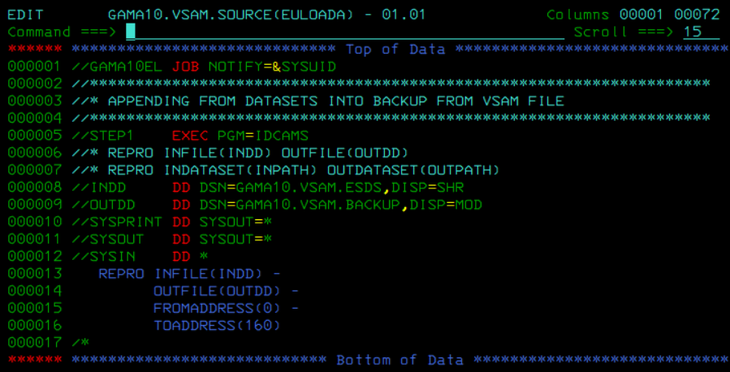

### Another way for selecting

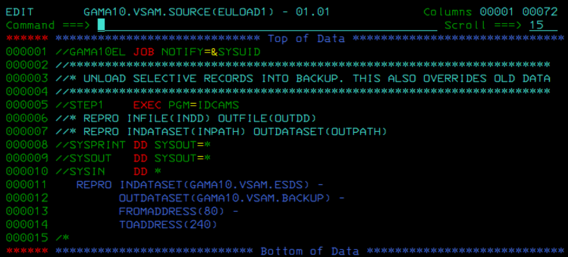

## PRINTING:

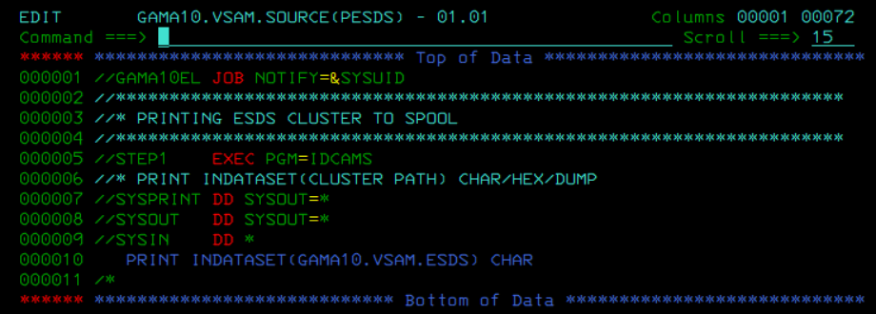

## ALTERNATE INDEX:

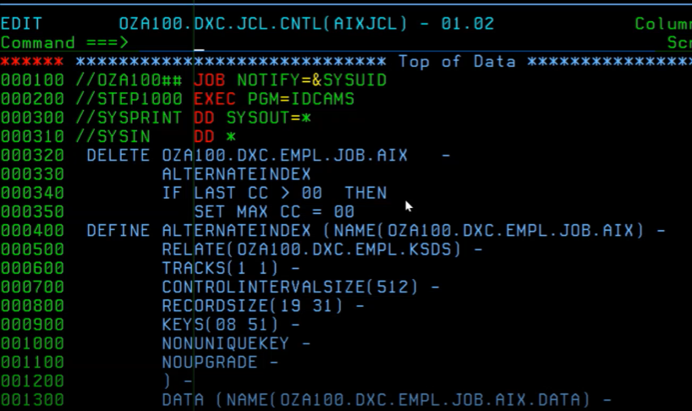

## VERIFY:

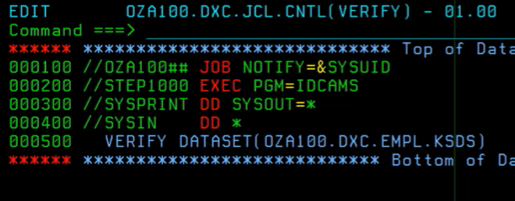

## LISTCAT:

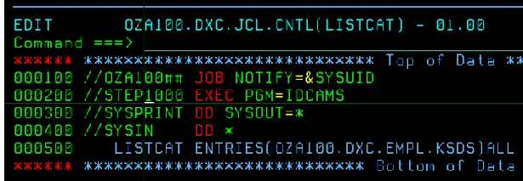

## 

# **DB2:**

Use Sql to query the Employee table for the following problems.

1. Display all the information of the emp table.
2. SELECT * FROM EMP_TBL
3. Display unique jobs from EMP table.
4. SELECT DISTINCT JOB FROM EMP_TBL
5. List the details of the emps in asc order of their salaries.
6. SELECT * FROM EMP_TBL ORDER BY SALARY ASC;
7. List the details of the emps in asc order of the WorkDeptnos and desc of Jobs.
8. SELECT * FROM EMP_TBL ORDER BY WORKDEPT ASC, JOB DESC;
9. Display all the unique job groups in the descending order
10. SELECT DISTINCT JOB FROM EMP_TBL ORDER BY JOB DESC;
11. Display all the details of all ‘Mgrs’
12. SELECT * FROM EMP_TBL WHERE JOB = ‘MANAGER’;
13. List the emps who joined before 1981.
14. SELECT * FROM EMP_TBL WHERE HIREDATE < ‘1981-01-01';
15. List the Empno, Ename, Sal, Daily Sal of all Employees in the ASC order of AnnSal.
16. SELECT EMPNO, FIRSTNME + ‘ ‘ + MIDINIT + ‘ ’ + LASTNAME AS ENAME, SALARY, ‘DAILY SALARY’ AS SALARY / 255 FROM EMP_TBL ORDER BY 'DAILY SALARY’ ASC;
17. SELECT EMPNO, FIRSTNME, SALARY, RTRIM(SALARY/365 DAILYSAL) FROM EMP_TBL ORDER BY SALARY * 12;

I. Divide salary by 365 days, then multiply by 12 when ordering.

1. Display the empno , ename, job, hiredate, exp of all Mgrs
2. SELECT EMPNO, FIRSTNME, JOB, HIREDATE FROM EMP_TBL WHERE JOB=’MANAGER’;
3. SELECT EMPNO, FIRSTNME, JOB, SALARY, MONTHS_BETWEEN(SYSDATE, HIREDATE)/12 WORKEX FROM EMP_TBL WHERE JOB=’MANAGER’;
4. List the empno, ename, sal, exp of all emps working for Mgr id 100.
5. SELECT * FROM EMP_TBL WHERE JOB=’MANAGER’ AND EMPNO=100;
6. SELECT EMPNO,FIRSTNME,SALARY, ONTHS_BETWEEN(SYSDATE, HIREDATE)/12 WORKEX FROM EMP_TBL WHERE JOB=(SELECT JOB=MANAGER FROM EMP_TBL B WHERE EMPNO=’000100’);
7. Display the details of the emps whose Comm. Is more than their sal.
8. SELECT * FROM EMP_TBL WHERE SALARY < COMM;
9. List the emps in the asc order of Designations
10. SELECT * FROM EMP_TBL ORDER BY CASE
11. JOB = ‘PRES’ THEN 1
12. JOB = 'MANAGER’ THEN 2
13. JOB = 'DESIGNER’ THEN 3
14. JOB = 'ANALYST’ THEN 4
15. JOB = 'CLERK’ THEN 5
16. And so on....
17. END ASC
18. SELECT * FROM EMP_TBL ORDER BY JOB ASC;
19. List the emps along with their exp and daily sal is more than Rs.100
20. SELECT CONCAT(FIRSTNME, CONCAT(‘ ‘, CONCAT(MIDINIT, CONCAT(‘ ’, LASTNAME)))) ENAME,

DATEADD(year, EDULVL, CURRENT_DATE - HIREDATE) EXP,

SALARY/365 DAILYSAL

FROM EMP_TBL WHERE DAILYSAL > 100;

SELECT EMPNO, CONCAT(FISTNME, LASTNME) FULLNAME, MONTHS_BETWEEN(SYSDATE,HIREDATE)/12 WORKEX, SALARY, FROM EMP_TABLE WHERE (SALARY/365) > 100

c. Results should have SALARY greater then 36,500

1. List the emps who are either ‘CLERK’ or ‘ANALYST’ in the desc order
2. SELECT * FROM EMP_TBL WHERE JOB=’CLERK’ OR JOB=’ANALYST’ ORDER BY JOB ASC
3. SELECT EMPNO, FIRSTNME, WORKDEPT, JOB FROM EMP_TBL WHERE JOB IN(‘CLERK’, ‘ANALYST’) ORDER BY EMPNO
4. List the emps who joined on 1May81,31Dec81, 17Dec81, 19Jan80 in asc order of seniority.
5. SELECT * FROM EMP_TBL WHERE HIREDATE=’1981-05-01' OR HIREDATE=’1981-12-31' OR HIREDATE=’1981-12-17' OR HIREDATE=’1980-01-19' ORDER BY HIREDATE ASC
6. SELECT EMPNO, FIRSTNME,  
   DECIMAL(MONTHS_BETWEEN(HIREDATE,SYSDATE)/12,5,2) WORKEX, FROM EMP_TBL WHERE HIREDATE LIKE ‘1981-05-01' OR ‘1981-12-31' OR ‘1981-12-17' OR ‘1980-01-19' ODER BY HIREDATE ASC;
7. List the emps who are working for the workdept D11 or E21
8. SELECT * FROM EMP_TBL WHERE WORKDEPT=’D11’ OR WORKDEPT=’E21’
9. SELECT EMPNO,FIRSTNME FROM EMP_TBL WHERE WORKDEPT=’D11’ OR WORKDEPT=’E21’
10. List the emps who are joined in the year 1981
11. SELECT * FROM EMP_TBL WHERE YEAR(HIREDATE)=1981
12. SELECT EMPNO, FIRSTNME FROM EMP_TBL WHERE CHAR(HIREDATE) LIKE ‘1981%’
13. Matches the date type casted to string against ‘1981%’ where it will match any string starting with 1981
14. List the emps who are joined in the month of Aug 1980
15. SELECT * FROM EMP_TBL WHERE HIREDATE BETWEEN DATE(‘1981-07-31') AND DATE(‘1981-09-01')
16. SELECT * FROM EMP_TBL WHERE YEAR(HIREDATE)=1981 AND MONTH(HIREDATE) =8
17. SELECT * FROM EMP_TBL WHERE CHAR(HIREDATE) LIKE ‘1981-08-__'
18. List the emps whose annul sal ranging from 22000 and 45000
19. SELECT * FROM EMP_TBL WHERE SALARY BETWEEN 22000 AND 45000
20. List the emps those are having five characters in their names.
21. SELECT * FROM EMP_TBL WHERE LENGTH(RTRIM(FISTNME))=5
22. SELECT EMP, FIRSTNME, FROM EMP_TBL WHERE FIRSTNME LIKE ’_____’
23. List the enames those are starting with ‘s’ and with fire characters
24. SELECT * FROM EMP_TBL WHERE LENGTH(RTRIM(FISTNME))=5 AND FISTNME LIKE ‘S%’
25. SELECT * FROM EMP_TBL WHERE FIRSTNME LIKE ‘S____’
26. List the emps those are having four chars and third char must be ‘r’
27. SELECT * FROM EMP_TBL WHERE LENGTH(RTRIM(FISTNME))=4 AND FISTNME LIKE ‘__R%’
28. SELECT * FROM EMP_TBL WHERE FIRSTNME LIKE ‘__R__’
29. List the 5 character names starting with ‘s’ and ending with ‘h’
30. SELECT * FROM EMP_TBL WHERE FISTNME LIKE ‘S%H’ AND LENGTH(RTRIM(FISTNME))=5
31. SELECT * FROM EMP_TBL WHERE FIRSTNME LIKE ‘S___H’
32. List the emps who joined in January
33. SELECT * FROM EMP_TBL WHERE MONTH(HIREDATE)=1
34. SELECT * FROM EMP_TBL WHERE CHAR(HIREDATE) LIKE ‘____-01-__'
35. List the emps who joined in the month of which second character is ‘a’
36. (MANUALLY SELECT MONTHS) SELECT * FROM EMP_TBL WHERE MONTH(HIREDATE)=1 OR MONTH(HIREDATE)=3 OR MONTH(HIREDATE)=5
37. SELECT * FROM EMP_TBL WHERE MONTH(HIREDATE) IN(1,3,5)
38. List the emps whose sal is 4 digit number ending with zero
39. SELECT * FROM EMP_TBL WHERE CHAR(SALARY) LIKE ‘___0.%’
40. List the emps whose names having a character set ‘ll’ together
41. SELECT * FROM EMP_TBL WHERE FISTNME LIKE ‘%LL%’
42. List the emps those who joined in 80’s
43. SELECT * FROM EMP_TBL WHERE YEAR(HIREDATE) BETWEEN 1980 AND 1989;
44. SELECT * FROM EMP_TBL WHERE YEAR(HIREDATE) >= 1980 AND YEAR(HIREDATE) <= 1989
45. SELECT * FROM EMP_TBL WHERE CHAR(HIREDATE) LIKE ‘198_-%’
46. List the emps who does not belong to Workdept A00
47. SELECT * FROM EMP_TBL WHERE NOT WORKDEPT=’A00’
48. List all the emps except ‘president’ & ‘Mgr’ in asc order of salaries
49. SELECT * FROM EMP_TBL WHERE NOT JOB=’PRESIDENT’ AND NOT JOB=’MANAGER’ ORDER BY SALARY ASC
50. SELECT * FROM EMP_TBL WHERE NOT JOB IN(‘MANAGER’,’PRESIDENT’) ORDER BY SALARY ASC;C

# **JCL BOOK:**

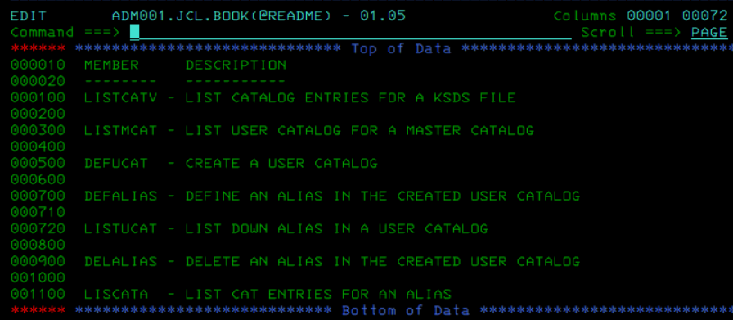

## ACDS:

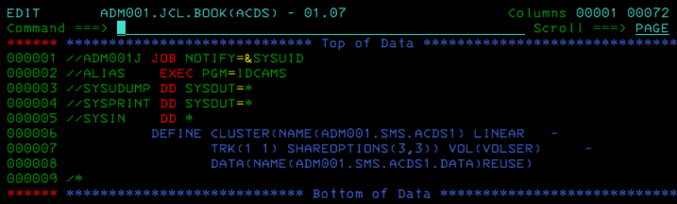

## COMMDS:

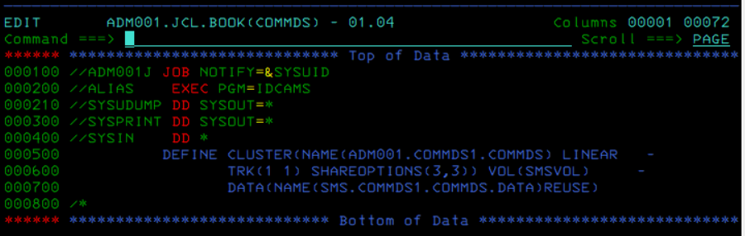

## DEFINE ALIAS:

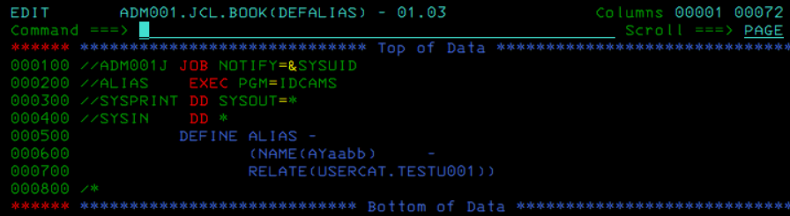

## DEFINE USER CATALOG:

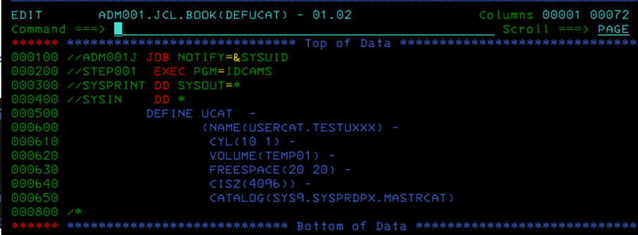

## DELETE ALIAS:

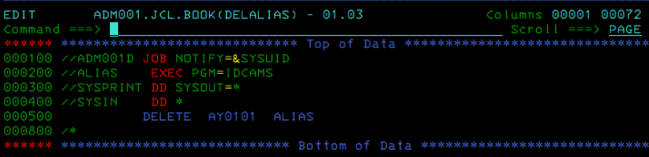

## DEFINING KSDS WITH IEFBR14

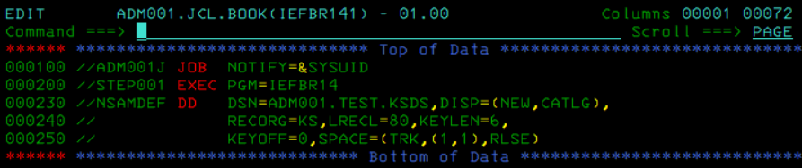

## DEFINING PDSE WITH IEFBR14 - change dsorg with dsntype

## LISTCAT All

## LIST ALL ENTRIES IN KSDS

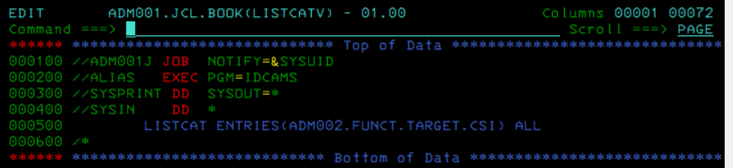

LIST ALL ENTRIES IN KSDS:

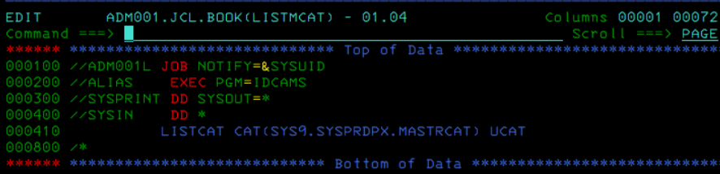

## LIST MASTER CATALOG:

## LIST USER CATALOG:

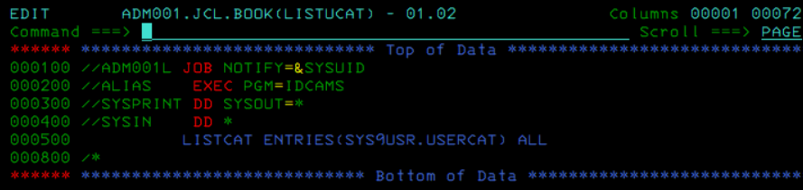

## SCDS:

